**PIZZA SALES SQL QUERIES**

1. **KPI’S**

**1.Total Revenue**

SELECT SUM(total_price) AS Total_Revenue FROM pizza_sales;

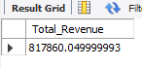

**2.Average Order value**

SELECT (SUM(total_price) / COUNT(DISTINCT order_id)) AS Avg_order_Value FROM pizza_sales;



**3.Total Pizzas sold**

SELECT SUM(quantity) AS Total_pizza_sold FROM pizza_sales;

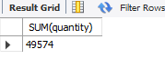

**4.Total Orders**

SELECT COUNT(DISTINCT order_id) AS Total_Orders FROM pizza_sales;

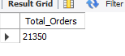

**5.Average Pizzas per order**

SELECT ROUND(SUM(quantity)/COUNT(DISTINCT order_id),2) AS Avg_pizzas_Per_Order FROM pizza_sales;

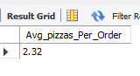

1. **HOURLY TRENDS FOR TOTAL PIZZAS SOLD**

SELECT extract(hour from order_time) AS Order_hour,

SUM(quantity) AS Total_Pizzas_Sold

FROM pizza_sales

GROUP BY extract(hour from order_time)

ORDER BY extract(hour from order_time);

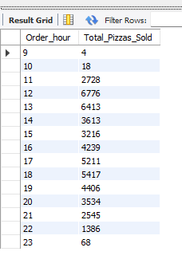

1. **HOURLY TRENDS FOR TOTAL PIZZAS SOLD**

SELECT week(order_date,3) AS Week_number,

YEAR(order_date) AS Order_year,

COUNT(DISTINCT order_id) AS Total_Orders

FROM pizza_sales

GROUP BY week(order_date,3), year(order_date)

ORDER BY week(order_date,3), year(order_date);

|  |  |
| --- | --- |
|  |  |

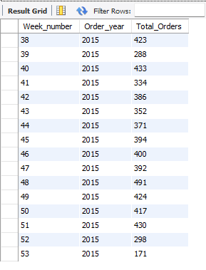

1. **PERCENTAGE OF SALES BY PIZA CATEGORY**

SELECT pizza_category, round(SUM(total_price),2) AS Total_sales,

round(SUM(total_price) * 100/(SELECT SUM(total_price) FROM pizza_sales),2) AS Pertage_Total_Sales

FROM pizza_sales

GROUP BY pizza_category;

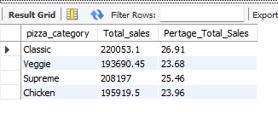

1. **PERCENTAGE OF SALES BY PIZZA SIZE**

SELECT pizza_size, round(SUM(total_price),2) AS Total_sales,

round(SUM(total_price) * 100/(SELECT SUM(total_price) FROM pizza_sales),2) AS Pertage_Total_Sales

FROM pizza_sales

GROUP BY pizza_size

ORDER BY Pertage_Total_Sales DESC;

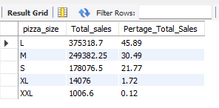

1. **TOTAL PIZZAS BY PIZZA CATEGORY**

SELECT pizza_category,

SUM(quantity) AS Total_Quantity_Sold

FROM pizza_sales

GROUP BY pizza_category

ORDER BY Total_Quantity_Sold DESC;

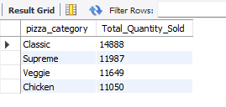

1. **TOP 5 PIZZAS BY REVENUE**

SELECT pizza_name,

SUM(total_Price) AS Total_Revenue

FROM pizza_Sales

GROUP BY pizza_name

ORDER BY Total_Revenue DESC

LIMIT 5;

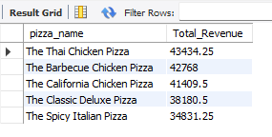

1. **BOTTOM 5 PIZZAS BY REVENUE**

SELECT pizza_name,

SUM(total_Price) AS Total_Revenue

FROM pizza_Sales

GROUP BY pizza_name

ORDER BY Total_Revenue

LIMIT 5;

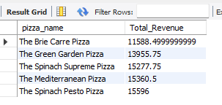

1. **TOP 5 PIZZAS BY QUANTITY**

SELECT pizza_name,

SUM(quantity) AS Total_Quantity

FROM pizza_Sales

GROUP BY pizza_name

ORDER BY Total_Quantity DESC

LIMIT 5;

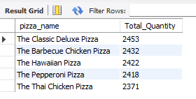

1. **BOTTOM 5 PIZZAS BY QUANTITY**

SELECT pizza_name,

SUM(quantity) AS Total_Quantity

FROM pizza_Sales

GROUP BY pizza_name

ORDER BY Total_Quantity

LIMIT 5;

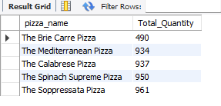

1. **TOP 5 PIZZAS BY TOTAL ORDERS**

SELECT pizza_name,

COUNT(distinct order_id) AS Total_Orders

FROM pizza_Sales

GROUP BY pizza_name

ORDER BY Total_Orders DESC

LIMIT 5;

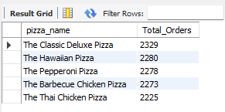

1. **BOTTOM 5 PIZZAS BY TOTAL ORDERS**

SELECT pizza_name,

COUNT(distinct order_id) AS Total_Orders

FROM pizza_Sales

GROUP BY pizza_name

ORDER BY Total_Orders

LIMIT 5;

